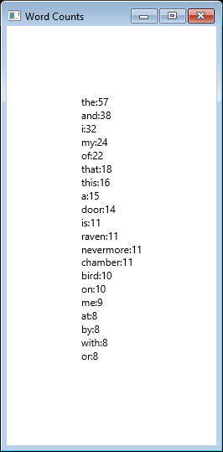

<https://github.com/splatterfest233/Software-Development-Class>